**DAILY ONLINE ACTIVITIES SUMMARY**

|  |  |  |  |  |  |  |  |  |
| --- | --- | --- | --- | --- | --- | --- | --- | --- |
| **Date:** | 27/05/2020 | | | | | **Name:** | BHAVYA.S | |
| **Sem & Sec** | 4th SEM ‘A’ SEC | | | | | **USN:** | 4AL18CS014 | |
| **Online Test Summary** | | | | | | | | |
| **Subject** | | Object Oriented Concepts(18CS45) | | | | | | |
| **Max. Marks** | | 30 | | **Score** | | | 26 | |
| **Certification Course Summary** | | | | | | | | |
| **Course** | INTRODUCTION TO PYTHON | | | | | | | |
| **Certificate Provider** | | | Great Learning | | **Duration** | | | 2.5 Hours |
| **Coding Challenges** | | | | | | | | |
| **Problem Statement:** 1. (Using C) To sort an array of integers in ascending order and display the  sorted array and number of passes performed for sorting. | | | | | | | | |
| **Status:** Completed | | | | | | | | |
| **Uploaded the report in Github** | | | | | YES | | | |
| **If yes Repository name** | | | | | <https://github.com/Bhavyamahadev/lockdown-coding> | | | |
| **Uploaded the report in slack** | | | | | YES | | | |

**Online Test Details:**

The online test was from module 5 which was about the Event Handling and Swings. There were 30 questions and the duration was 30 minutes. The questions were optimal and were easy. The score that I got in the test is 26/30.

**Snapshot:**

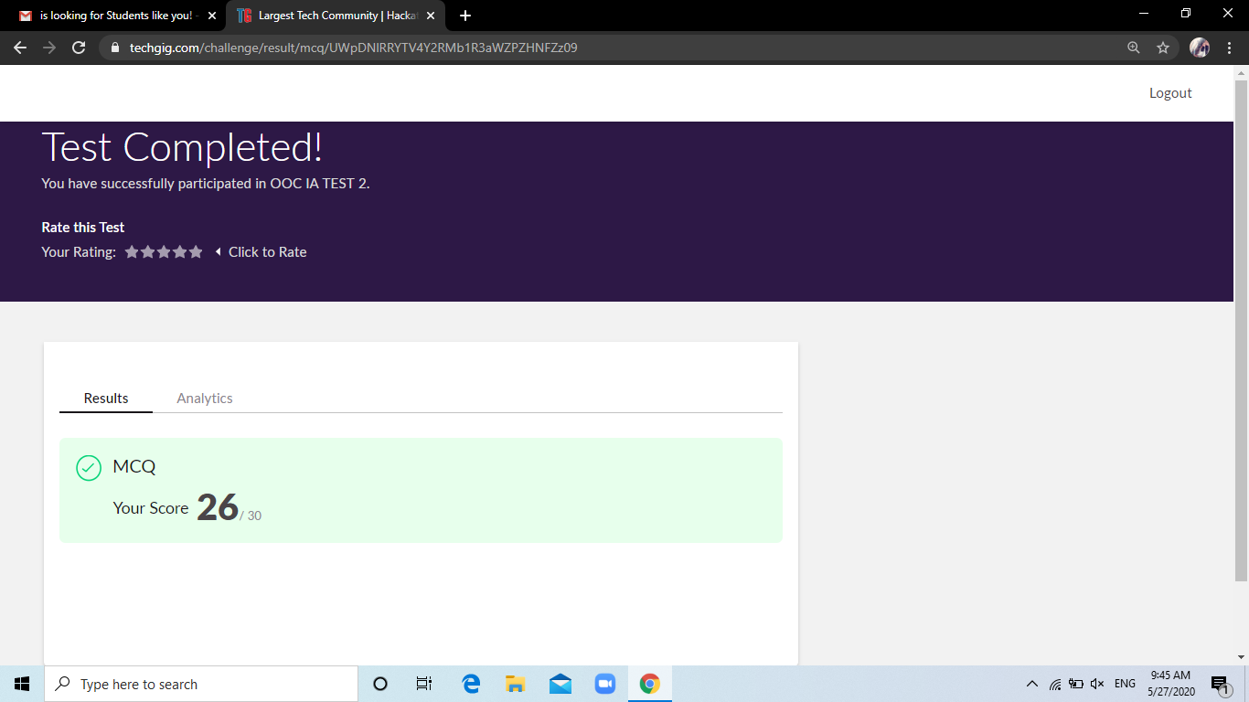

**Certification Course Details:**

**Name of the course**: operators in python

**Certificate Provider**: Great Learning

Today I went through the first section of the course that explained about operators in python. I have gone through the R overview and preliminary steps, Data types, Data structures, Importing data, Data manipulations, Sorting and merging.

**Snapshot:**

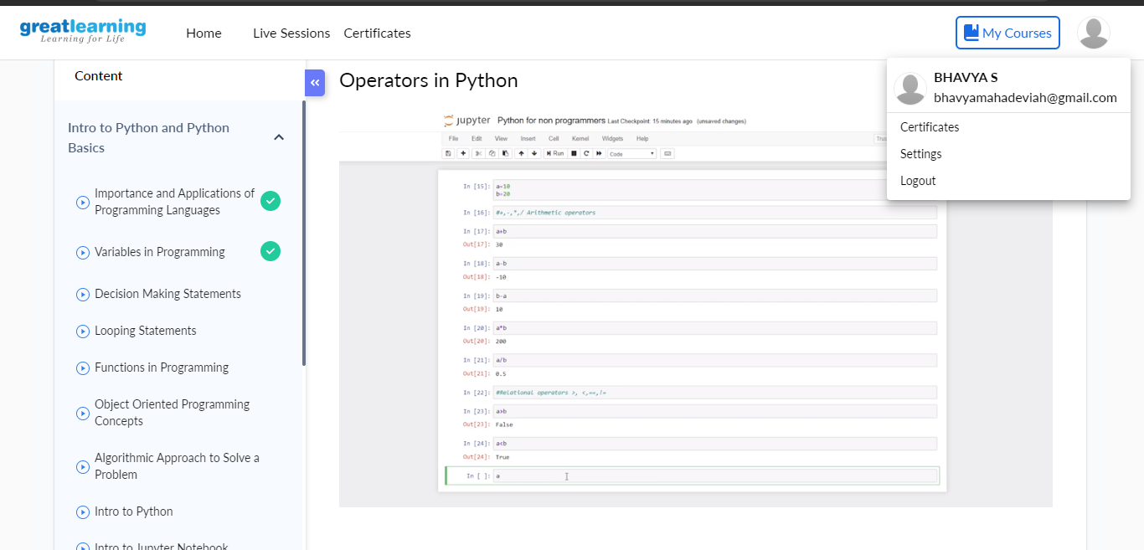

**Online Coding Details:**

Problem 1: (using C language) To sort an array of integers in ascending order and display the

sorted array and number of passes performed for sorting.

**Snapshot:**

